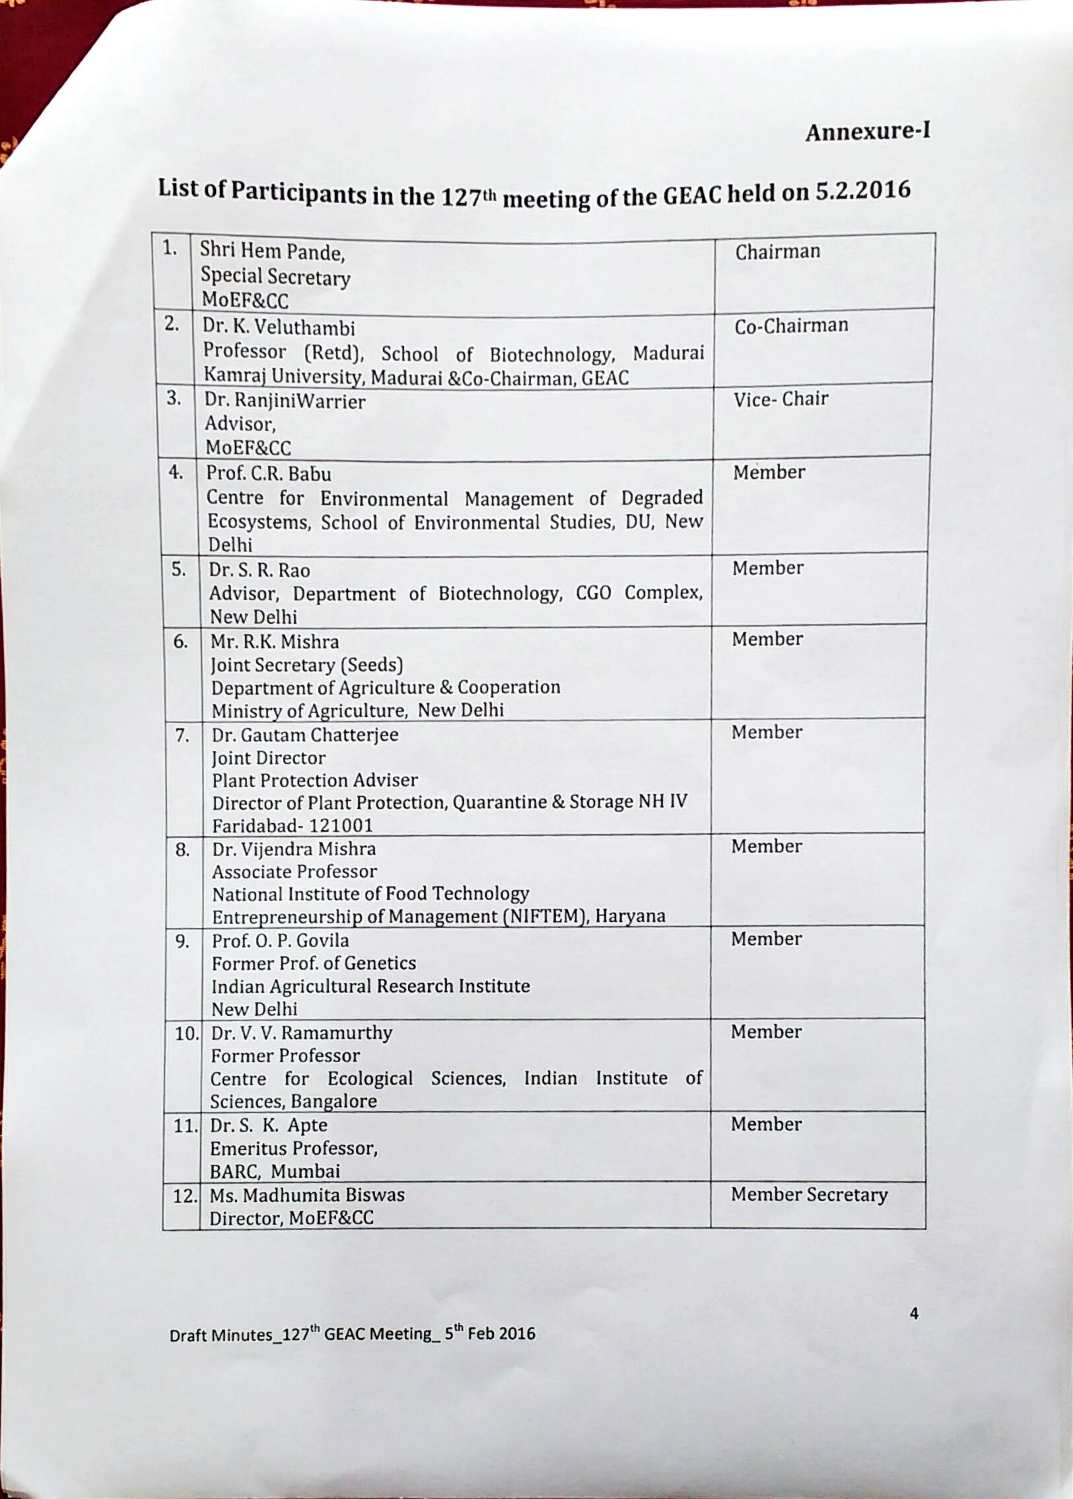

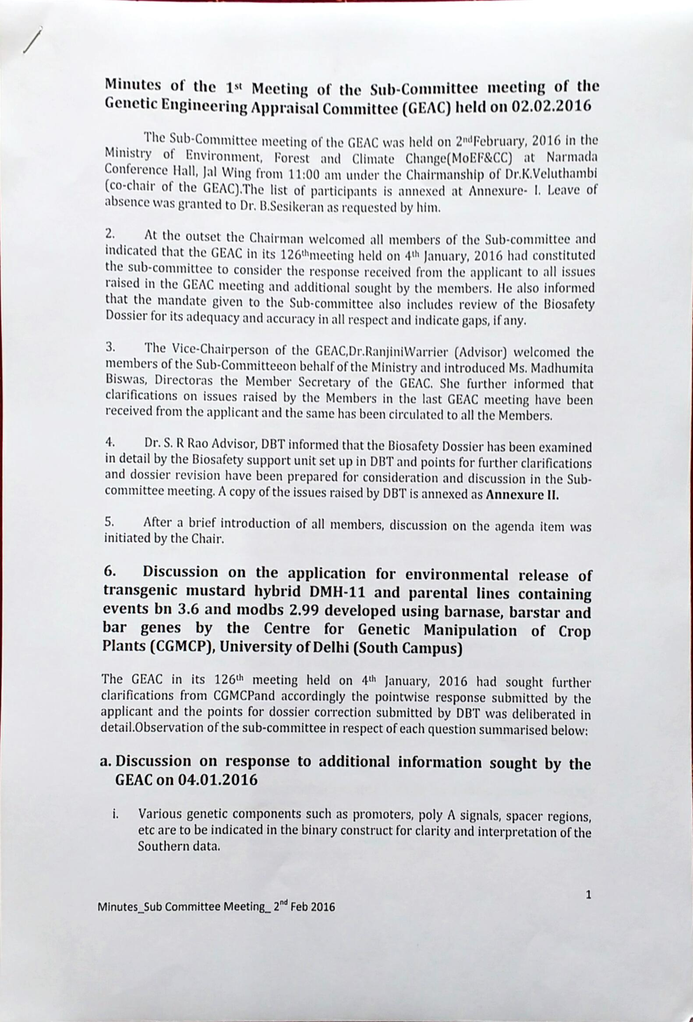

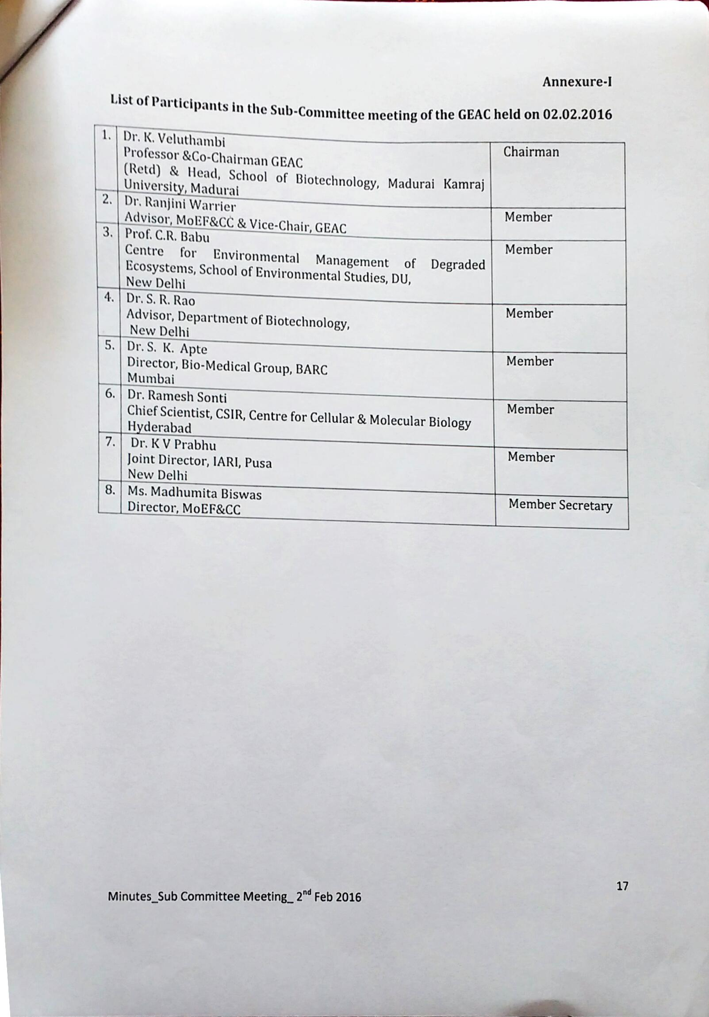

130th Meeting:





**Minutes of the 128th meeting of the Genetic Engineering Appraisal Committee (GEAC) held on 04.03.2016**

The 128th meeting of the GEAC was held on 4th March, 2016 in the Ministry of Environment, Forest and Climate Change (MoEF&CC) at Narmada Conference Hall, Jal Block from 11:00 am under the Chairmanship of Shri Hem Pande, Special Secretary, MoEF&CC.

List of participants is annexed at **Annexure-I.**

At the outset, the Chairman welcomed all the Members of the GEAC and requested Ms. Madhumita Biswas, Director and Member Secretary, GEAC to initiate discussion on the agenda items.

**Agenda item No. 1: Leave of absence**

The Committee granted leave of absence to Prof V Veluthambi, Co-Chair, GEAC, Dr. Luther Rangreji, Dr. B. Sesikeran, Prof S K Apte, Dr Vijay Kumar, ICMR, Dr. Ramesh Sonti as requested by them.

It was also informed that a communication has been received from Dr A K Pradhan that he will abstain from the meetings of the GEAC till the time the matters on GM mustard are under consideration in the GEAC.

**Agenda item No.2** : Confirmation of minutes of 127th meeting of the GEAC held on 05.02.2016

2.1 Minutes of the 127th meeting were circulated to all members on 08.02.2016. Minutes were confirmed without any amendments.

**Agenda item No.3** : Action taken report on the decision taken in the 127th GEAC Meeting

The Committee noted that pursuant to the 127th GEAC meeting, M/s. CGMCP, University of Delhi has submitted the revised biosafety dossier in respect of their application for environmental release of transgenic mustard. It was also noted that Coalition for a GM-Free India was invited to present their objections and concerns on the transgenic mustard application in the GEAC meeting but they have conveyed their regrets due to other prior commitments and have requested for an alternate date.